**UML Assignment**

1. Design and draw UML class diagram to represent an airline reservation system. The system

enables the customer to search for airline flight on a specified date and choose a flight based

on some details like availability. The customer can reserve a flight or cancel his reservation.

The system displays all the flight details such as flight number, name, price and duration of

journey.

<https://lucid.app/lucidchart/e23ef0f2-6019-4f8d-9a2b-09781e5ac8d1/edit?viewport_loc=-847%2C-127%2C3609%2C1737%2C0_0&invitationId=inv_feaf1b25-1da9-4fd6-b0cb-2c065f5540a7>

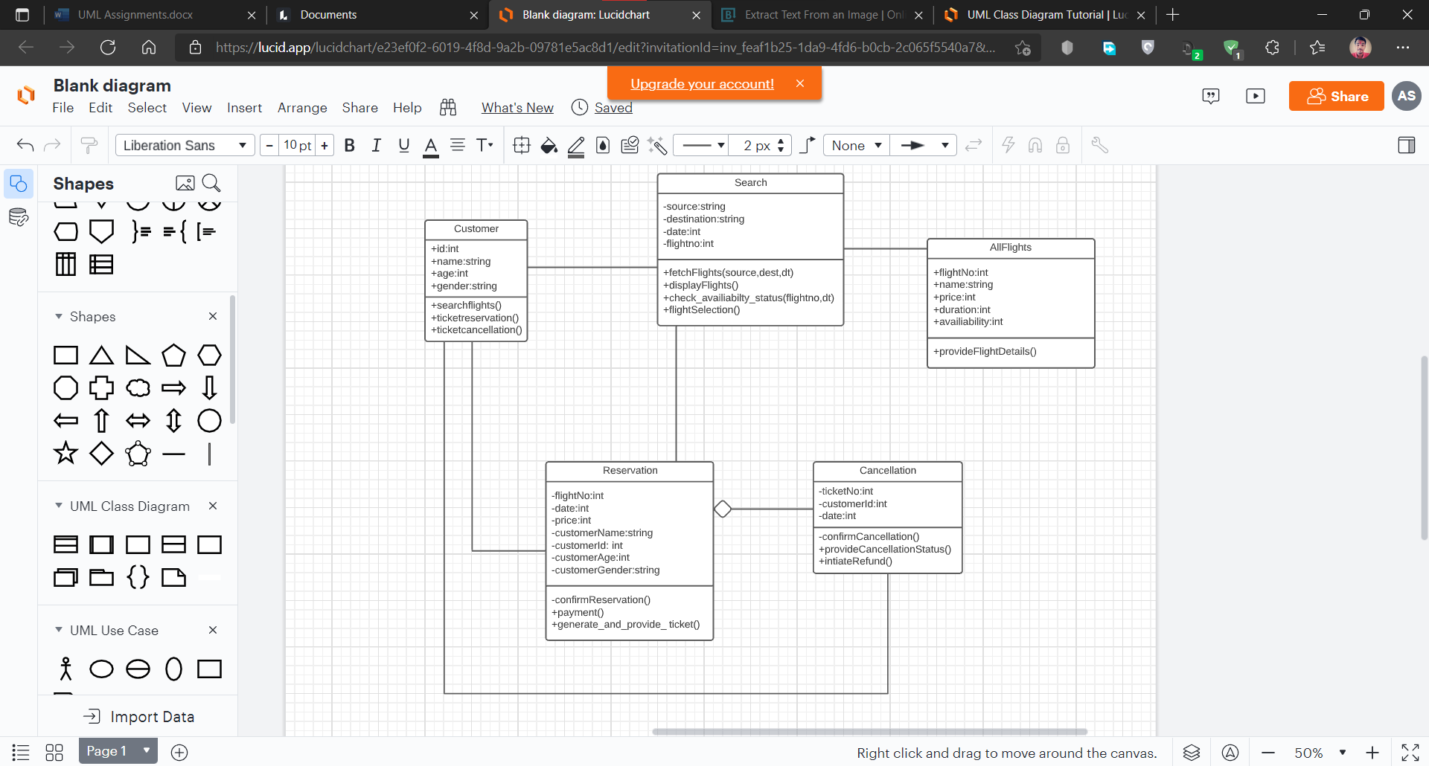

2. Design and draw UML class diagram with attributes, behaviour, and class relationships for

the following scenario.

In a university there are various departments. A department has a name and is associated to

classrooms and offices. An employee working at the university has a unique Id and can be a

professor or an instructor. A professor can be a full professor, associate professor, or

assistant professor and he/she belongs to a department in the university. Offices and

classrooms also have unique IDs and classrooms have fixed number of seats. Also, every

employee is assigned an office.

<https://lucid.app/lucidchart/eb138a2f-d6b6-4a84-8a33-4ad5decceb16/edit?viewport_loc=-76%2C28%2C2560%2C1232%2C0_0&invitationId=inv_27e29ed4-1404-4195-8247-c36185f7d4db>

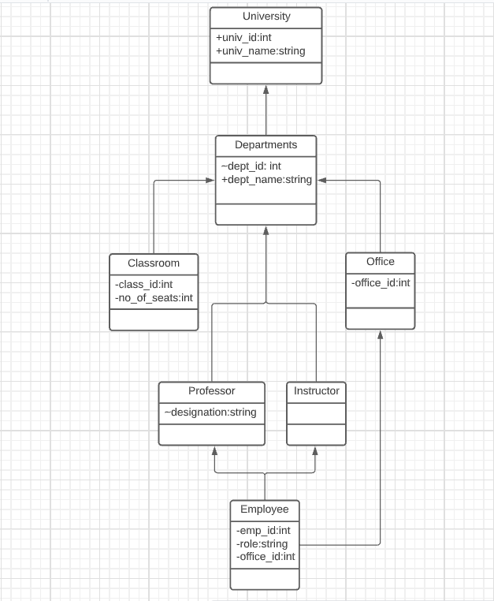

3.Draw an activity diagram for the given scenario where a student needs to enrol with the university for the given course.

Process for student enrolment in the university is as follows:

* An applicant wants to enrol in the university.
* The applicant hands a filled-out copy of Enrolment Form.
* The registrar inspects the forms.
* The registrar determines that the forms have been filled out properly.
* The registrar informs student to attend in university overview presentation.
* The registrar helps the student to enrol in seminars
* The registrar asks the student to pay for the initial tuition.

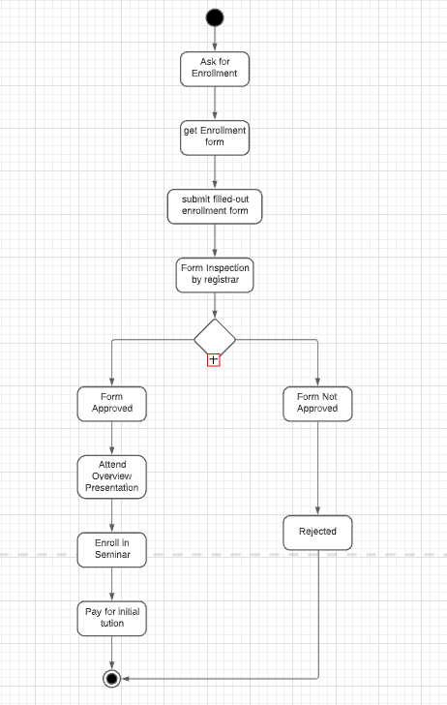

4. A scenario of Online Library Management System is given below. You need to refer the use

case diagram and moving further need to create a sequence diagram for the same.

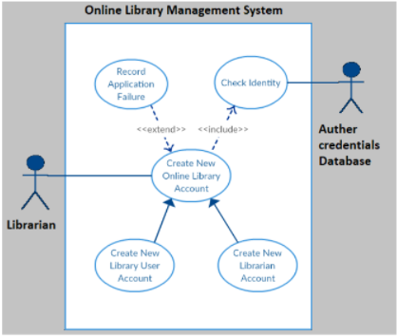

Here are the steps that occur in the given use case named 'Create New Library User Account'.

* The librarian requests the system to create a new online library account
* The librarian then selects the library user account type
* The librarian enters the user's details
* The user's details are checked using the user Credentials Database
* The new library user account is create
* A summary of the new account's details is then emailed to the user.  
    
  